**Assignment Part 1**

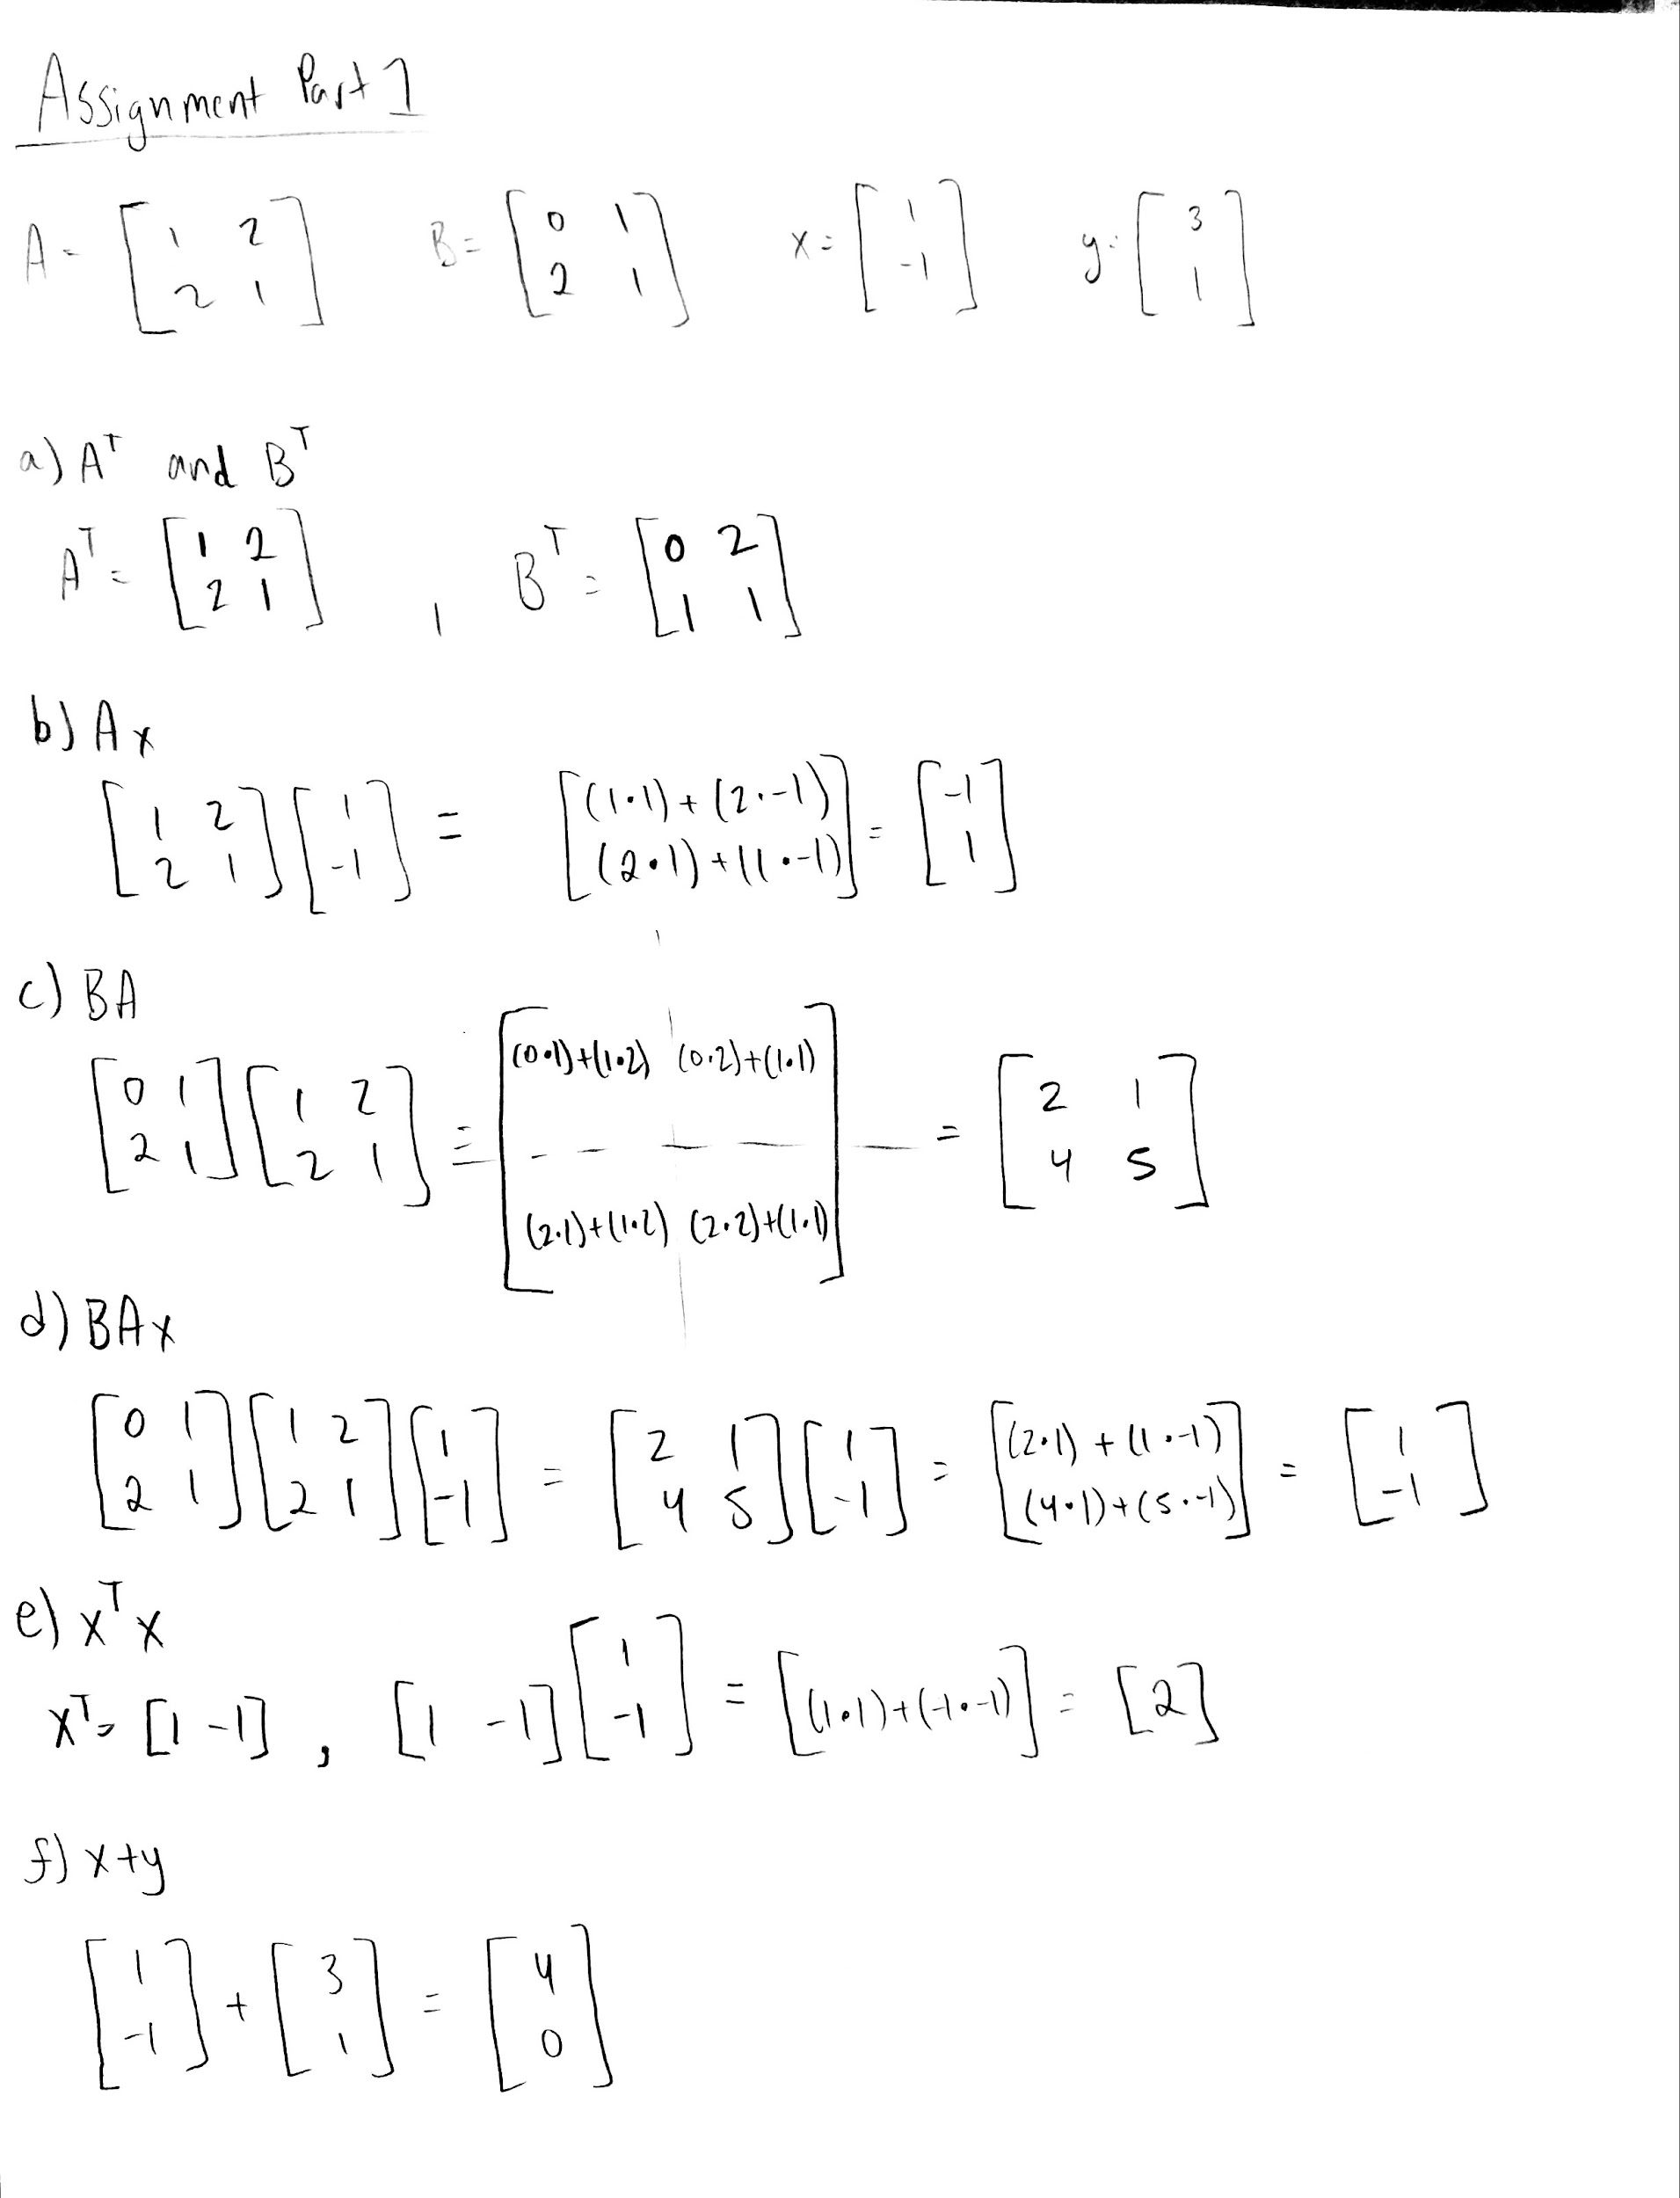

**Assignment Part 2**

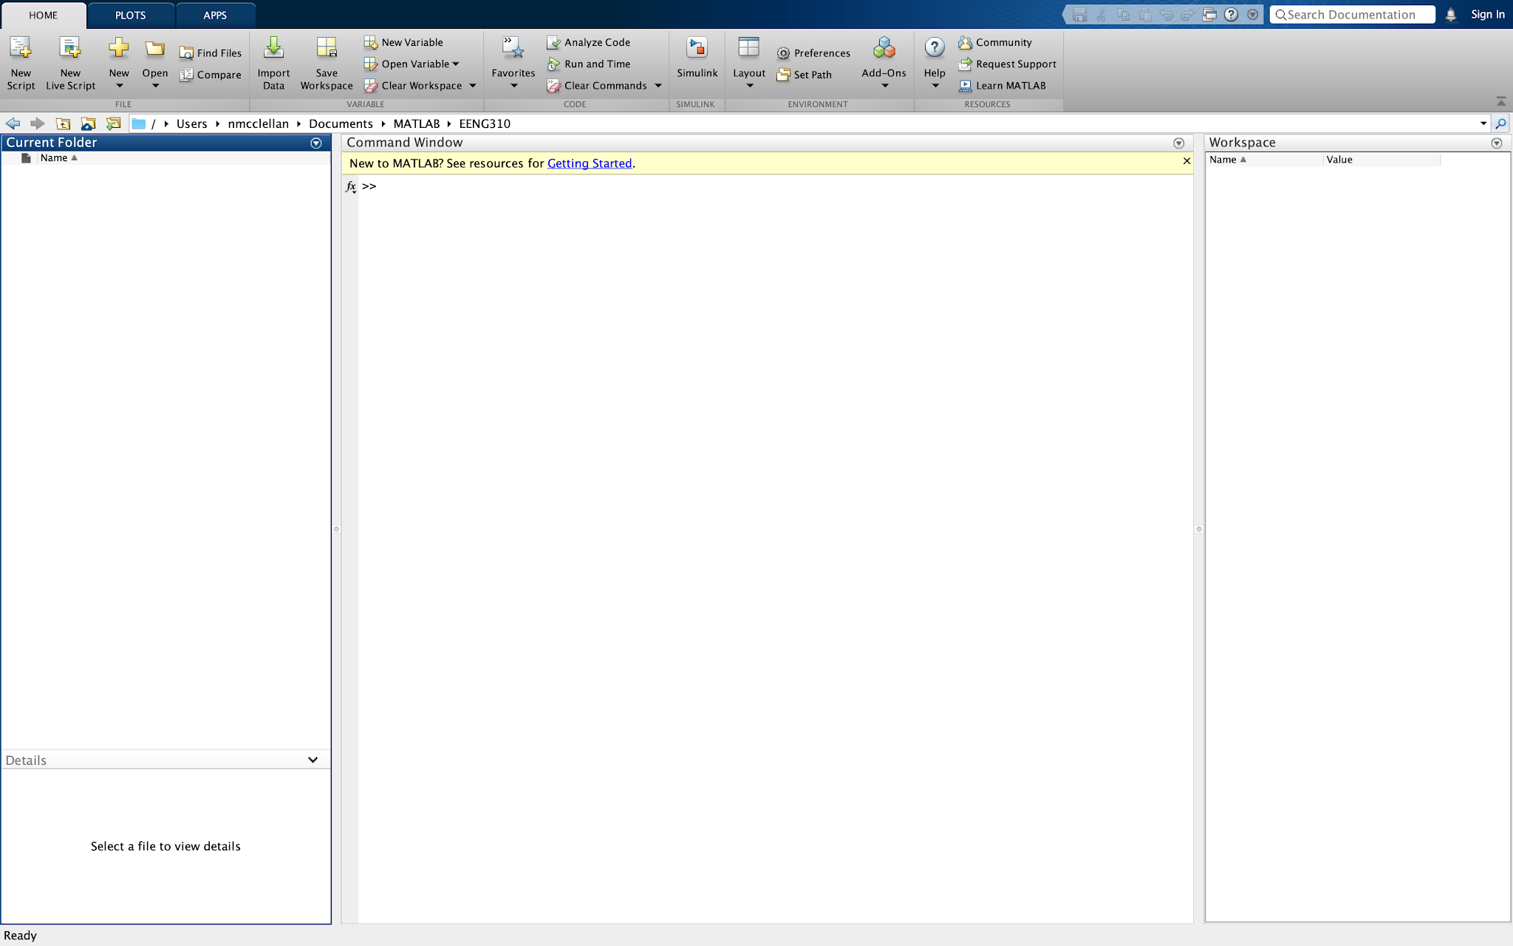

**Assignment Part 3**

**Question 3.**

(a).

(b).

(c).

(d).

**Question 4.**

>> A = [1,2;2,1];

>> B = [0,1;2,1];

>> x = [1;-1];

>> y = [3;1];

>> A'

ans =

1 2

2 1

>> B'

ans =

0 2

1 1

>> A*x

ans =

-1

1

>> B*A

ans =

2 1

4 5

>> B*A*x

ans =

1

-1

>> x' * x

ans =

2

>> x+y

ans =

4

0

**Question 5.**

a = exp(j*[0:(pi/10):(2*pi)])

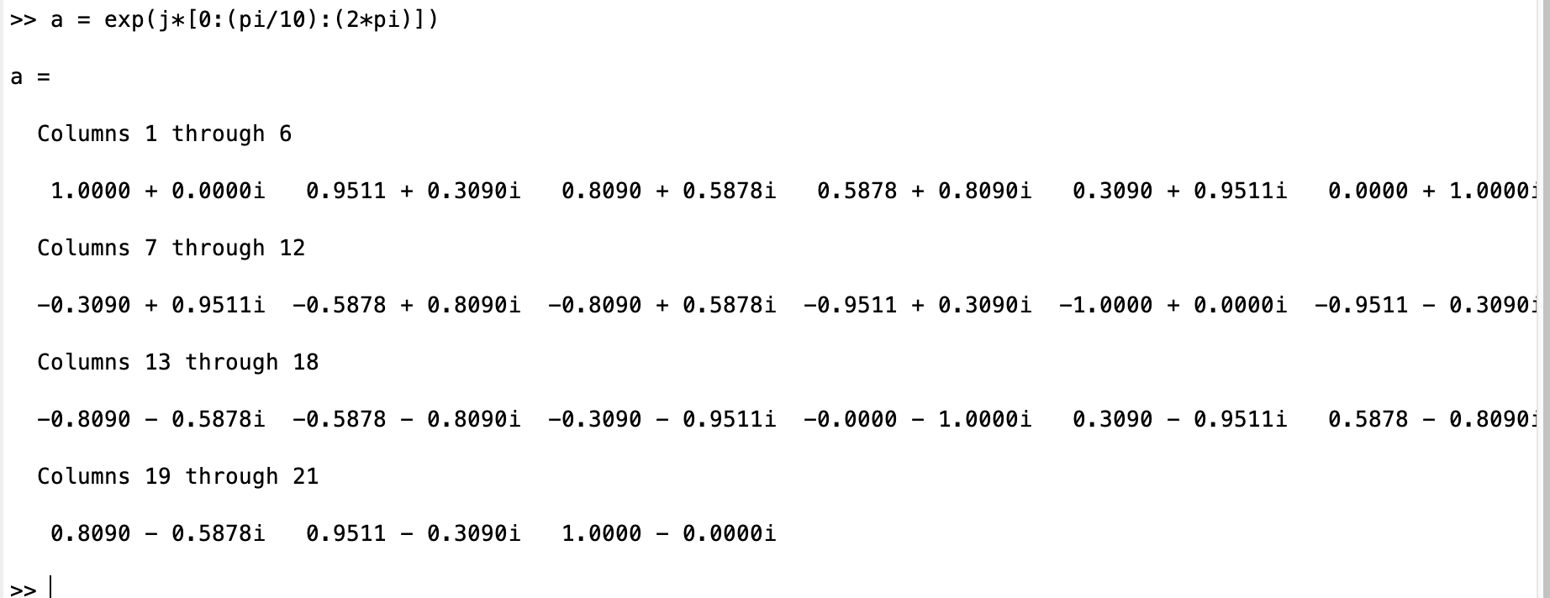

**Assignment Part 4**

**Question 6.**

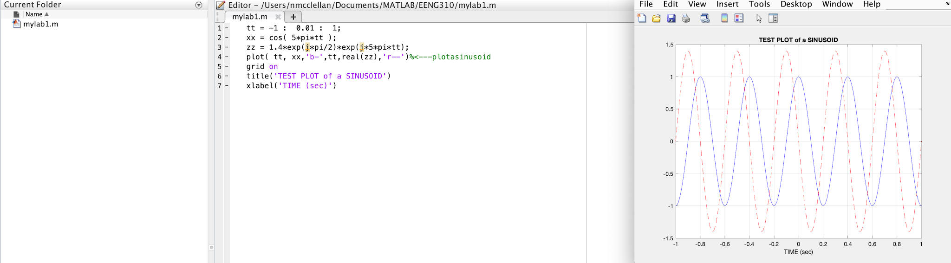

The “b-” command is what causes the line to be both blue and solid. Similarly, the “r--” command gives the line a red and dashed appearance.

**Question 7.**

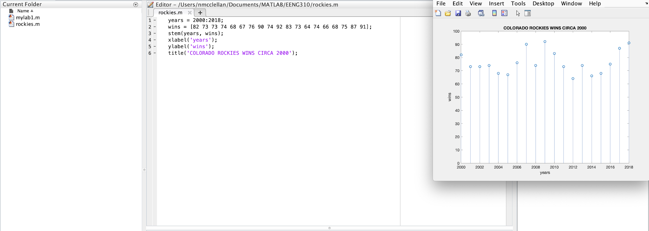

**Question 8.**

The command to find the size of matrix A, would be size(A). Further, the first dimension given is the number of rows, and the second dimension is the number of columns.